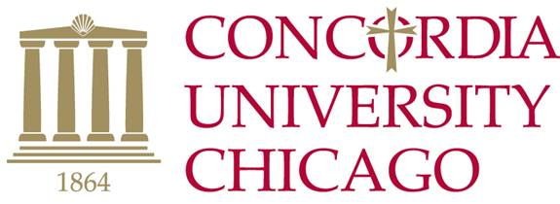
Synodical Placement
Approval Recommendations

The Synodical Placement Approval Committee (SPAC) meets once each semester to approve the Synodical placement of those students graduating at the end of the current semester. For their review, three recommendations from at least one theology faculty and two current full time faculty are required. Please verify that they are full time faculty and not adjunct.

It is not necessary for you to obtain the actual recommendations. All you have to do is request permission to use them as a reference and then indicate their names below. The Placement Office will then forward a form for each of them to complete.

NOTE: Forms for those graduating in December MUST be turned in no later than October 1 to be included for consideration at the fall SPAC meeting.

(Theology Department Faculty Member)

(Faculty Member)

(Faculty Member)

Student Name

